Laycee Glass
OFM4 Task 1
Data Mining II
3/4/25
Western Governors University

OFM4 Performance Assessment, Task 1

Student Information
Student Name: Laycee Glass
ID Number: 001896026
Date: 3/4/25

Part I: Research Question

A1. Research Question
The question I posed for this task was: Can we identify clusters of patients based on demographic information and complication risk?

A2. Goal of Analysis
The goal of this analysis was to identify groups of patients based on their demographic information (age, gender, income, etc.) and complication risk level. Identifying such groups was important because it could help the hospital system enhance risk management and improve patient satisfaction by addressing the needs of high-risk populations, if present.

Part II: Technique Justification

B1. Clustering Technique
Hierarchical clustering is a technique used to group similar data based on their characteristics. In this analysis, it helped identify meaningful patient clusters using demographic information and complication risk. The process begins by treating each patient as its cluster and then repeatedly merging the most similar clusters based on a chosen distance metric. This hierarchical structure is visualized by a dendrogram to determine the optimal number of clusters.
By applying hierarchical clustering, we expect to identify distinct groups of patients, such as those at a higher risk for complications versus those at a lower risk, as well as potential demographic influences. These insights can help the hospital system improve risk management, allocate resources effectively, and develop targeted strategies for high-risk populations.

B2. Assumption
When using hierarchical clustering, there are some assumptions we should acknowledge. The objects in the dataset should be comparable based on the chosen distance metric, meaning that similar data points should belong to the same cluster. The effectiveness of clustering depends on selecting an appropriate distance metric, such as Euclidean distance for numerical data.
Also, the variables should be measured on an appropriate scale. This ensures meaningful distance calculations. Standardizing variables may be necessary to prevent larger-scaled features from dominating the clustering process (Hierarchical cluster analysis, 2024).

B3. Packages/Libraries
To complete this assessment, I used the following packages and libraries in Python:
- pandas – data manipulation
- sklearn – evaluation of clustering through silhouette score
- matplotlib/seaborn – visualizations
- scipy – linkage, fcluster, and dendrogram functions

Part III: Data Preparation

C1. Preprocessing Goal
As stated earlier, for hierarchical clustering to effectively produce distinct clusters, standardization of the variables was necessary. This allowed for all variables to contribute equally to the clustering process and prevented any single variables from dominating due to scale differences. I used StandardScaler because it standardizes the data by giving each variable a mean of 0 and a standard deviation of 1.

C2. Variables
The variables used for this analysis were the following:
Continuous
- Children
- Age
- Income
Categorical
- Marital
- Gender
- Complication_risk

C3. Steps of Data Preparation and Code
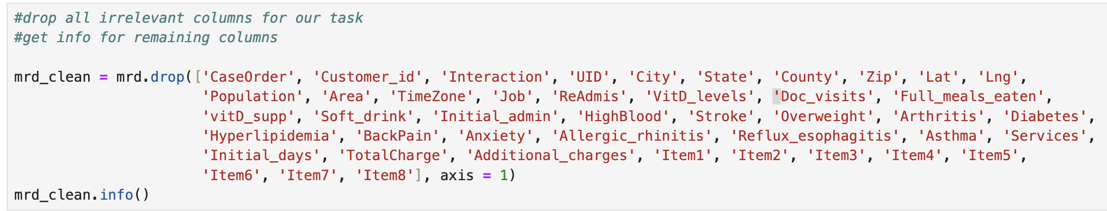
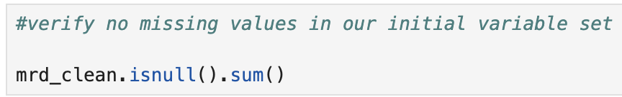
Much of the code to prepare the data for the clustering process borrows from my previous coursework – dropping irrelevant columns, identifying missing values, visualizing outliers, renaming columns, etc. The code for each portion of cleaning/preprocessing is shown below:
There were no missing values, and as such, nothing had to be done.

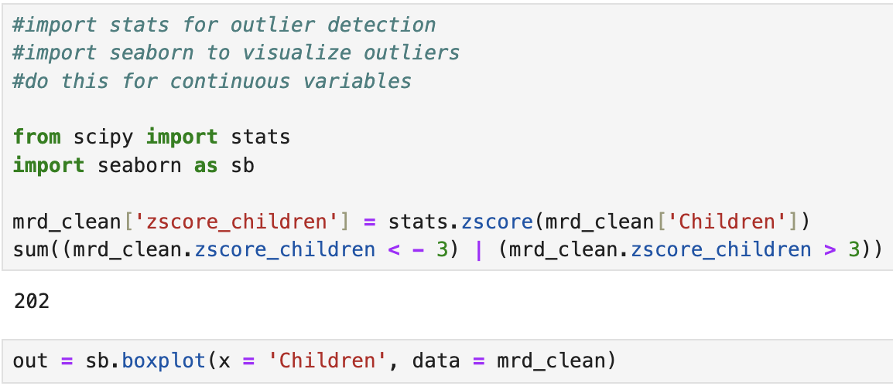
All outliers were retained because the values were expected. None were dropped, imputed, or changed in any way, just kept as is. The created zscore columns were dropped, using much of the same code as shown above when dropping the irrelevant columns to start. The next steps involved re-expressing variables for the clustering process, as it requires variables to be numeric since it relies on distance to create clusters. The code for this is shown below:
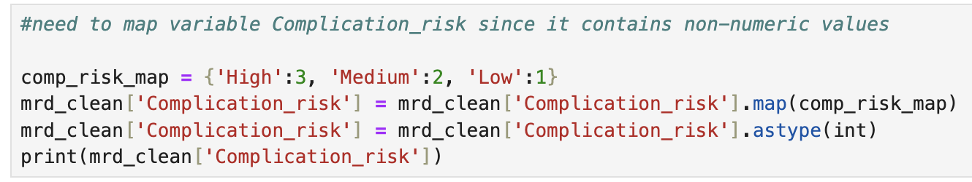
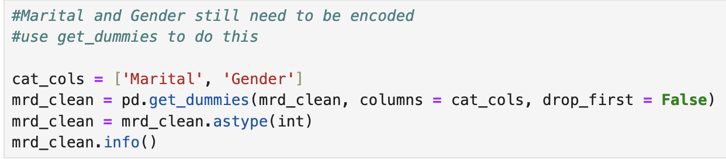

After the variables had been encoded properly, the continuous variables needed to be scaled. This prevented the larger-scale variables from dominating the process. This code is shown below:

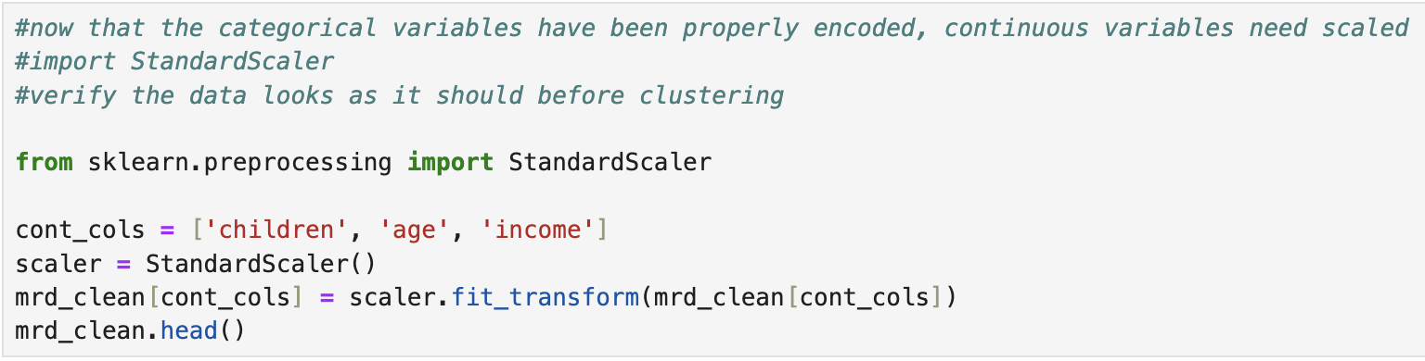
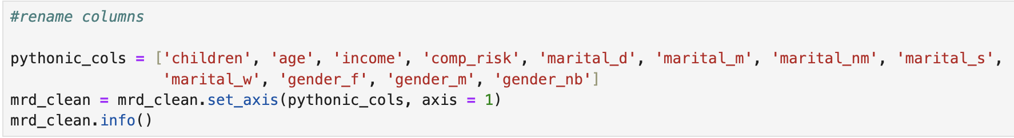
Once the continuous variables had been scaled using StandardScaler, the last part of preprocessing was to rename the variables for ease of use. This code is shown below:

C4. Cleaned Data Set
Once the data had been preprocessed, it was then exported to its own CSV file for submission. The code for this is shown below:

Part IV: Analysis

D1. Number of Clusters
To determine the optimal number of clusters, I experimented with three hierarchical clustering linkage methods: single, complete, and Ward’s. The single linkage method produced a dendrogram that was difficult to interpret and seemingly non-decipherable. The complete linkage method was impractical, as it caused multiple kernel crashes. Ward’s method, however, generated a clear and interpretable dendrogram that revealed four distinct clusters.
To validate this result, I analyzed cluster size distributions and silhouette scores. The four-cluster solution resulted in 2019, 686, 3745, and 3550 observations per cluster, with cluster two appearing much smaller than the others. Because of this, I calculated silhouette scores for 2, 3, 4, and 5 clusters, finding that three clusters yielded the highest score (0.158). Thus, I determined that three clusters provided the most optimal and well-separated grouping for the dataset.

D2. Code
The dendrogram was created using the following code:

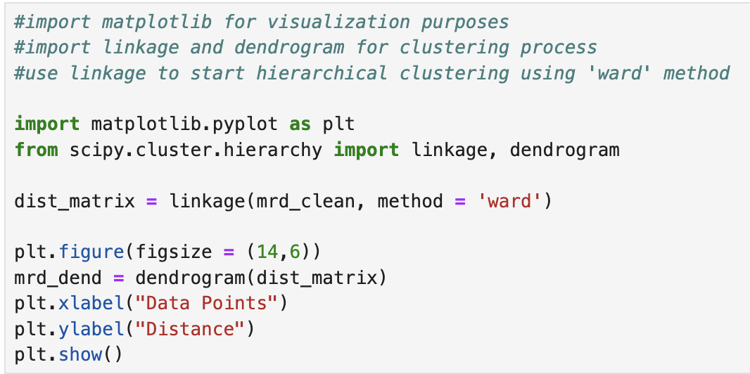

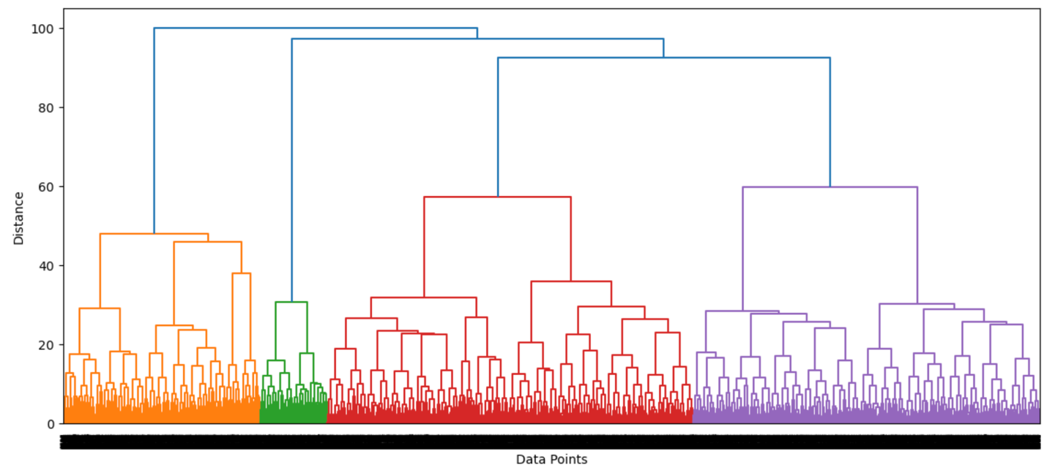
The dendrogram itself is shown below:

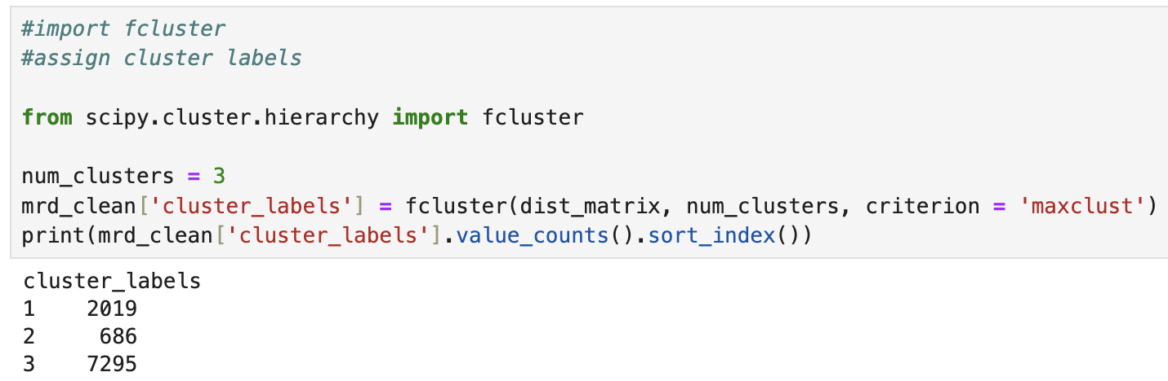
Then, fcluster was used to identify the segmentation of the clusters and gave us the number of observations per cluster. This is shown below:
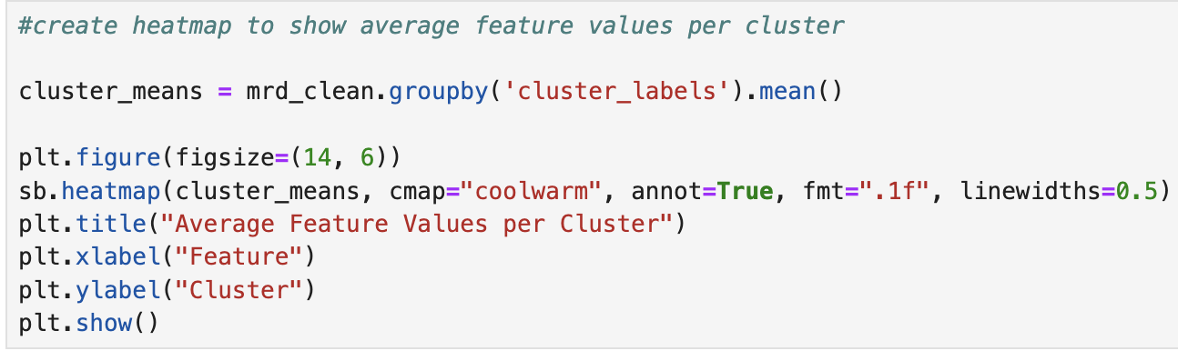
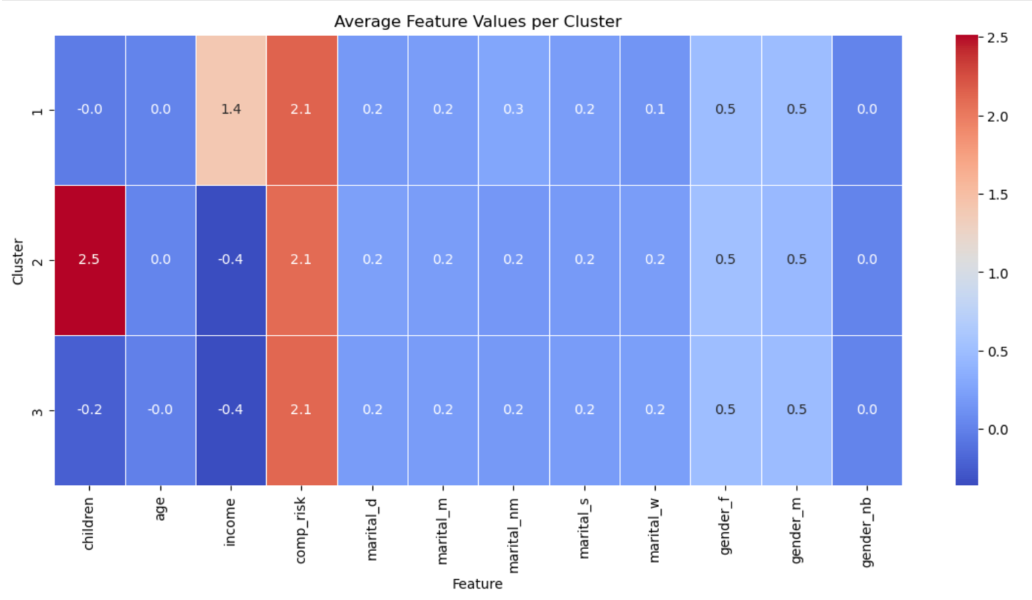
An average features per cluster heatmap was created to highlight the characteristics per cluster. This is how clusters were identified (cluster 1 had higher income than average, cluster 2 had lower income than average, etc). The creation of this, and the subsequent heatmap, is shown below:
Evaluation of the clustering was done by calculating the silhouette score. Silhouette score, and its interpretation relevant to our model is discussed further in section E1. This code is shown below:

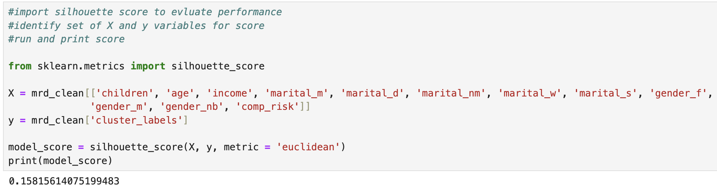
Finally, I generated a t-SNE model of our clusters to give a visual representation. This was done by import TSNE and 3DAxes (GeeksforGeeks, 2024). This is discussed more thoroughly in section E1. The code, and subsequent model, is shown below:
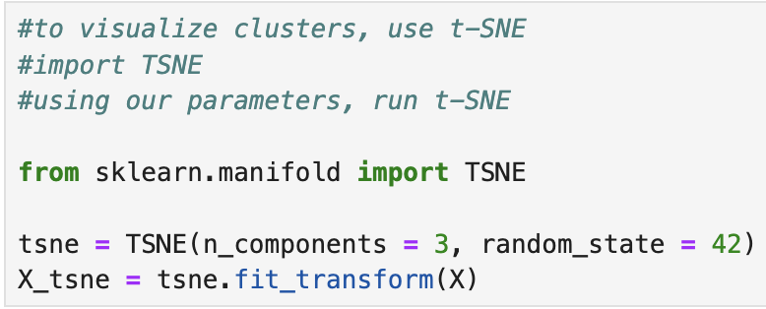
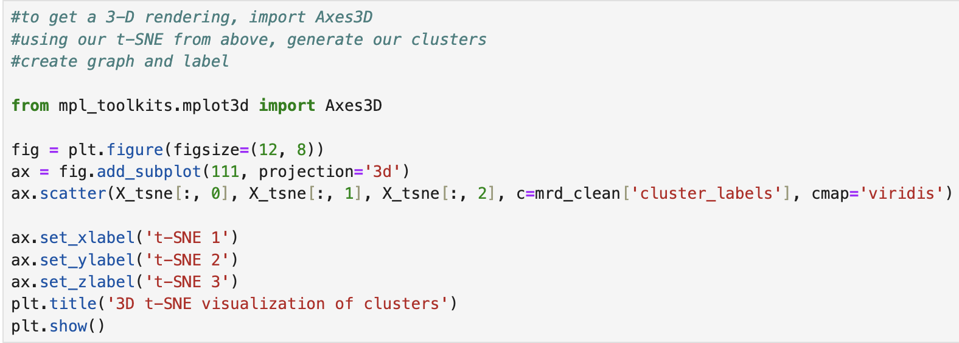
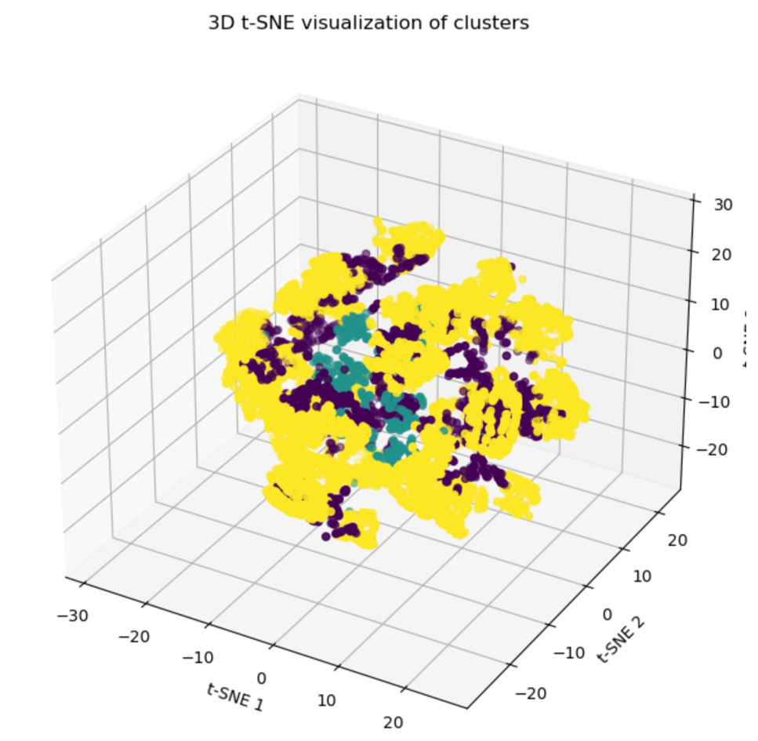

Part V: Data Summary and Implications

E1. Cluster Quality
As stated, the model had a silhouette score of 0.158. Silhouette scores range from -1 to 1. A negative score close to -1 indicates that points have generally been assigned to the wrong clusters. A positive score close to 1 implies that points are far away from neighboring clusters. A score of 0 indicates that points are close to the boundaries of neighboring clusters, often resulting in overlap. Our score of 0.158 was only slightly above 0, suggesting that there is some overlap between our clusters (Koli, 2023).
This observation is further supported by the t-SNE model that was generated. The 3-D visualization shows three clusters that are in close proximity to each other, with no distinct separation between them. This overlap indicates the clusters are not well-defined in the feature space.
Overall, the clustering model is neither exceptionally good nor bad. While the model does identify some groupings, there is a lack of clear separation. This suggests room for improvement.

E2. Results and Implications
The hierarchical clustering split the data into three groups:

Cluster 1:
- Patients with higher income than average
- Patients with an average number of children

Cluster 2:
- Patients with a higher number of children than average
- Patients with a lower income than average

Cluster 3:
- Patients with an average number of children
- Patients with a lower income than average

Based on these characteristics, cluster 1 could represent a patient population that is less likely to face financial challenges related to healthcare costs. These patients may be more proactive in health management, possibly seeking preventative care more frequently or accessing wellness programs.
Cluster 2, with its higher number of children and lower income, could represent a population with less access to healthcare. The additional family responsibilities may limit their time and ability to advocate for their own care. This group may benefit from targeted interventions, such as financial assistance programs or additional support services to help them access appropriate care.
Cluster 3 shares similarities with cluster 2 in terms of income but has fewer children on average. Despite this, the lower income could still pose challenges to healthcare access. Like cluster 2, this group may benefit from financial assistance programs. They could also be a target for outreach programs aimed at improving access to care.
Interestingly, complication risk, along with age, gender, and marital status, appeared to be the same (or very similar) across all clusters. This means the clusters were not based on these factors. This may suggest there were no specific high-risk clusters, but it does not diminish the need for targeted care solutions in general.
Even without complication risk discrepancies, general admission reduction programs, free pop-up health fairs/clinics, follow-up phone calls, and other outreach efforts could benefit these groups and improve the well-being of patients in all three clusters.

E3. Limitation of Analysis
A major limitation of this analysis was feature selection. While I chose a subset of features related to patient demographics and complication risk, other factors like past medical history, lifestyle behaviors, and specific medical conditions could provide a more separated and meaningful set of clusters.

E4. Course of Action
Although I touched on some recommendations earlier, I will reiterate and expand on them here. Based on the features of the created clusters, I recommend implementing general programs that benefit all patient populations since the complication risk was the same across all clusters. Programs could include follow-up care programs, free health fairs and low-cost clinics, and virtual care options.
Follow-up care programs ensure patients are following medication instructions, attending necessary appointments, and tracking vitals or other aspects of their health if needed. These check-ins, whether automated phone calls or text messages, can help improve compliance and health outcomes.
Free health fairs and low-cost clinics provide a more accessible option for patients with financial constraints. Offering health screenings, vaccinations, and other preventative care measures at a lower cost can also help improve patient health outcomes.
Virtual care options, such as telehealth visits and remote monitoring, if feasible and applicable, can help patients manage their health more conveniently and cost-effectively. This reduces the need for in-person visits that may require copays or additional costs. It provides patients with another way to be proactive about their health.
Beyond these recommendations, another course of action would be improving data collection and broadening feature selection. More data almost always provides better context and generalizability of the results, and incorporating additional features could lead to more distinct, meaningful clusters. At that point, targeted and more specific interventions could be implemented for even better outcomes.

Part VI: Demonstration

F1. Panopto Recording
A Panopto recording of the code and its execution has been submitted alongside this written report.

G. Code Sources
D212 DataCamp courses
Prior D206-D209 coursework for data cleaning
GeeksforGeeks. (2024, March 15). Make 3D interactive matplotlib plot in Jupyter Notebook. https://www.geeksforgeeks.org/make-3d-interactive-matplotlib-plot-in-jupyter-notebook/

H. Text Sources
Hierarchical cluster analysis in SPSS - explained, performing test. Statistical Analysis Services For Academic Researches. (2024, October 21). https://spssanalysis.com/hierarchical-cluster-analysis-in-spss/#:~:text=Here%20are%20the%20key%20assumptions%20of%20hierarchical,on%20an%20appropriate%20scale%20(interval%2C%20ratio%2C%20etc.).
Koli, S. (2023, March 2). How to evaluate the performance of clustering algorithms using silhouette coefficient. Medium. https://medium.com/@MrBam44/how-to-evaluate-the-performance-of-clustering-algorithms-3ba29cad8c03

